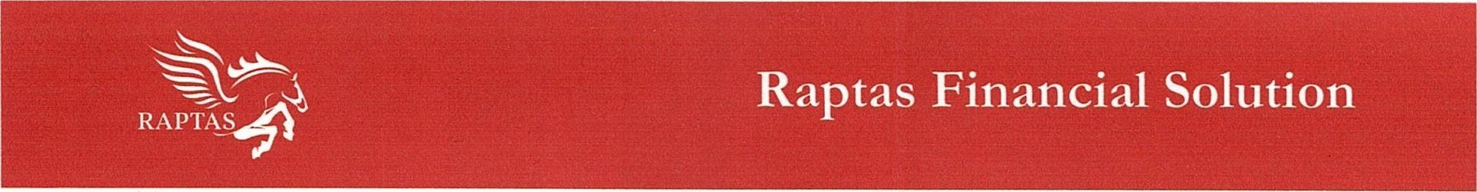
DECLARATION & CONSENT FORM

[I/We], the Directors/Partner/ Sole Proprietor/ Authorised Signatories of M/s ____________________ (“Applicant(s)"), hereby unconditionally and irrevocably declare and confirm that:
I/We represent that all the particulars and information (“Information”) given in the customer information document (“Application”) are true, correct and complete in all respect.
I/We acknowledge and understand that RAPTAS Financial Solution Private Limited (the “Consultant”) may decide to recommend to Financial Institution (“Bank”) to grant the Applicant financial facilities (“Facilities”) as requested by the Applicant based on the Information provided by the Applicant through the Application and through various other documents.
I/We undertake to provide any further information as the Consultant may require from time to time including the documents required for complying with the Know Your Customer (KYC) requirements for further loan process.
I/We further agree and understand that the Bank in its sole discretion may reject the Application and the decision of the Bank shall be final and binding on us. Files and documents once submitted to RAPTAS Financial Solution Private Limited, in any form, will not be returned to us due to use of stamping and OSV on the file and documents.
I/We confirm and agree that the Bank may/would be required to furnish any information regarding the Applicant and me/ us in the capacity of the Director / Partner/ Sole Proprietor/ Authorised Signatory of the Applicant to these service providers/agents.
I/We, in the capacity of the Director / Partner/ Sole Proprietor/ Authorised Signatory of the Applicant have no objection in and give consent to you (RAPTAS Financial Solution Private Limited) for sharing any information of the Applicant and my/our account details including my/our personal details to your recommended financial intuitions, affiliates, services providers, agents, surveyors, agencies, credit bureaus, etc., in India, to enable you, the Bank, to provide the Facilities / services to the Applicant under the banking arrangement/agreements including customized solutions and marketing services.
I/We state that my/our aforesaid authorization shall be valid till my/our written communication of withdrawal of my/our consent is acknowledged by RAPTAS Financial Solution Private Limited.
I/We understand and accept the risks involved in sharing personal information including sensitive personal information like bank account details with RAPTAS Financial Solution Private Limited.
“I/We hereby declare and confirm that any or all information provided by me or my authorized representative and or my nominee (mentioned below) is true, authentic and accurate in all respects and shall not tantamount to fabrication of facts in any way.”
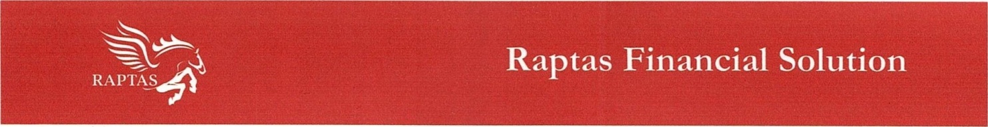

Name of nominee: _______________
I/We agree that services provided by RAPTAS Financial Solution Private Limited to the Applicant /me/us could be suspended/discontinued, if I/We withdraw my/our consent.
I/We have read, understood and acknowledge and agree that the RAPTAS Financial Solution Private Limited may refer to bank about my/our name / Applicant, and/or information related to me/us / Applicant to a recognized credit or referencing agency/ies/ Credit Bureau/ Bank /Financial Institution and/or make such references and enquiries as the Bank may consider necessary.
Firm Name, Stamp and Signature :____________________

Authorised Signatory Name :_________________________

Designation:_____________________________________

Place And Date: _________________________________

